EASO and IOM sign Working Arrangement

* 22ND JULY 2019

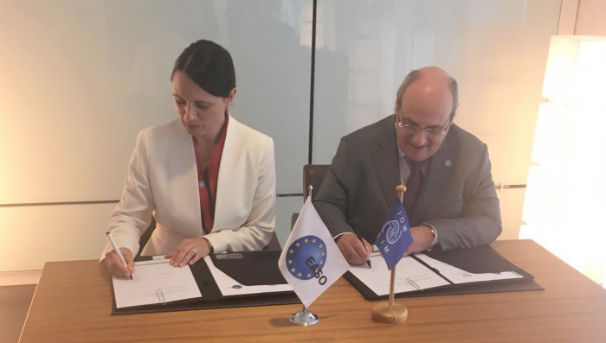

***The European Asylum Support Office (EASO) and the International Organization for Migration (IOM) have established a formal cooperation framework to guide the relevant areas of common work in the fields of international protection and migration management.***

The [Working Arrangement](http://kno6.mjt.lu/lnk/AMIAAEU81RAAAchbFrQAAFwvGhgAAP-N-BkAF-fcAAliiABdNZnVWHEY_9KLTQyT8fku-IdyZgAI5Wk/1/MzCMduwzCBmAxxLUnx5hrA/aHR0cHM6Ly93d3cuZWFzby5ldXJvcGEuZXUvc2l0ZXMvZGVmYXVsdC9maWxlcy9lYXNvLWlvbS13b3JraW5nLWFycmFuZ2VtZW50LnBkZg) was signed today by the Executive Director of EASO, **Nina Gregori**, and the Director General of the IOM, **António Vitorino**, in Paris.

The Working Arrangement covers cooperation in several areas where EASO and the IOM’s mandates converge in ensuring that the rights of migrants and applicants for international protection are safeguarded, while supporting national governments in meeting their obligations and needs. These areas include early warning, preparedness and contingency, the reception conditions of applicants, returns to countries of origin, resettlement, voluntary relocation and supporting migrants with vulnerabilities and specific protection needs.

Cross-cutting areas of cooperation are also included in the Working Arrangement, such as training initiatives, exchange of expertise and joint work on capacity-building activities for national authorities.

Commenting on the signing of the Working Arrangement, Nina **Gregori**stated: *“EASO and the IOM have worked together for several years in helping authorities safeguard the rights of migrants and applicants for international protection. I welcome today’s formalization of this cooperation, which strengthens the important work both parties carry out and is another example of the EU’s emphasis on strong international synergies in migration and asylum management.”*

António **Vitorino**said: *“Partnership between IOM and EASO has seen significant expansion in the last few years, reflecting the growth and complexity of needs in the field of asylum and migration in the EU and neighbouring countries. Establishing cooperation for complementarity is a pre-cursor for ensuring highest-quality support to migrants, asylum-seekers and our shared Member States.”*

EASO and the IOM also work together to support countries in the European neighbourhood in managing migration and asylum procedures in line with international and, where applicable, EU law. This includes joint training to national authorities, the coordination of resettlement from non-EU countries to the EU as well as the exchange of data, information and documentation.